# ***Wrangle and Analyze Twitter Data***

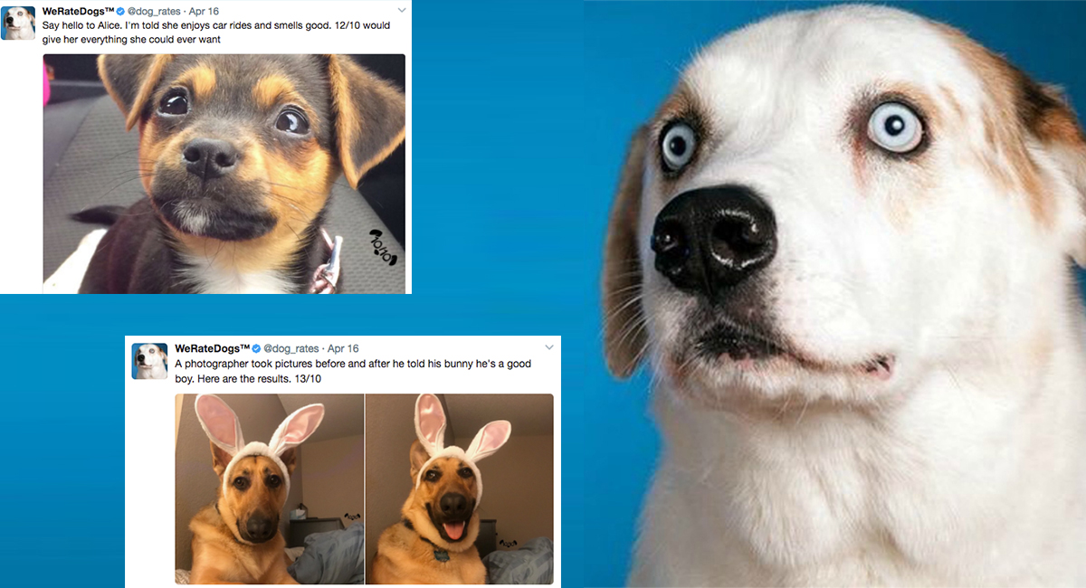

**Introduction**

Real-world data rarely comes clean. Using Python and its libraries, you will gather data from a variety of sources and in a variety of formats, assess its quality and tidiness, then clean it. This is called data wrangling. You will document your wrangling efforts in a Jupyter Notebook, plus showcase them through analyses and visualizations using Python (and its libraries) and/or SQL.

The dataset that you will be wrangling (and analyzing and visualizing) is the tweet archive of Twitter user **[@dog\_rates](https://twitter.com/dog_rates" \t "_blank)**, also known as **[WeRateDogs](https://en.wikipedia.org/wiki/WeRateDogs" \t "_blank)**. WeRateDogs is a Twitter account that rates people's dogs with a humorous comment about the dog. These ratings almost always have a denominator of 10. The numerators, though? Almost always greater than 10. 11/10, 12/10, 13/10, etc. Why? Because "**[they're good dogs Brent](http://knowyourmeme.com/memes/theyre-good-dogs-brent" \t "_blank)**." WeRateDogs has over 4 million followers and has received international media coverage.

WeRateDogs **[downloaded their Twitter archive](https://support.twitter.com/articles/20170160" \t "_blank)** and sent it to Udacity via email exclusively for you to use in this project. This archive contains basic tweet data (tweet ID, timestamp, text, etc.) for all 5000+ of their tweets as they stood on August 1, 2017. More on this soon.

**Data Visualization**

Cleaned and improved data were used to visualize and infer essential takeaways to the tweet data .

**graph 1:** Plotting a scatterplot between favorites and retweets.

The outcomes from this plot are as follows:

* A number of tweets happen to have less than 10,000 retweets.
* A lot of tweets tend to have fewer than 40,000 favorites.

**graph 1:** Bar Chart for Dog Stages.

The outcomes from this bar chart are as follows:

* Dog stages are not the same, the doggo count is over 200 on pupper .
* The pupper have the highest counts and the floofer have the fewest counts.